## Problem 2 – IT Blog

Create a Web site (HTML5 + CSS3 + images) that looks and behaves like the screenshots below:

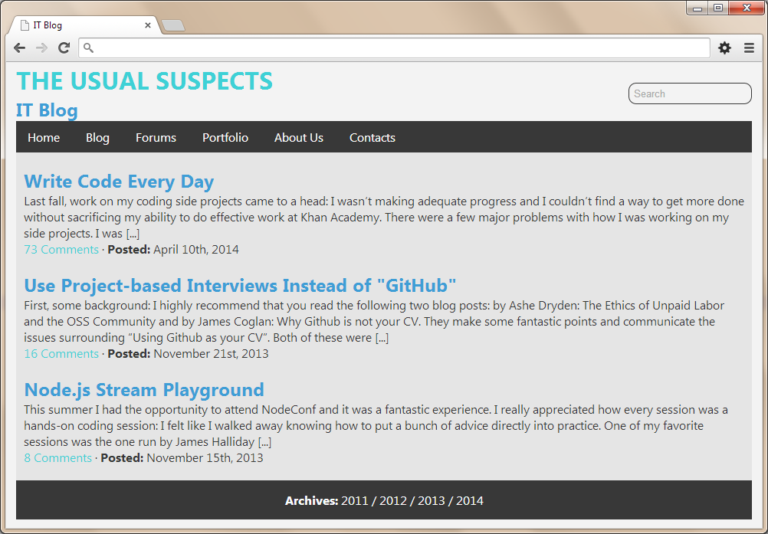

http://www.clipartbest.com/cliparts/4Tb/G59/4TbG59GTg.pnghttp://www.clipartbest.com/cliparts/4Tb/G59/4TbG59GTg.pnghttp://www.clipartbest.com/cliparts/4Tb/G59/4TbG59GTg.pnghttp://www.clipartbest.com/cliparts/4Tb/G59/4TbG59GTg.pnghttp://www.clipartbest.com/cliparts/4Tb/G59/4TbG59GTg.png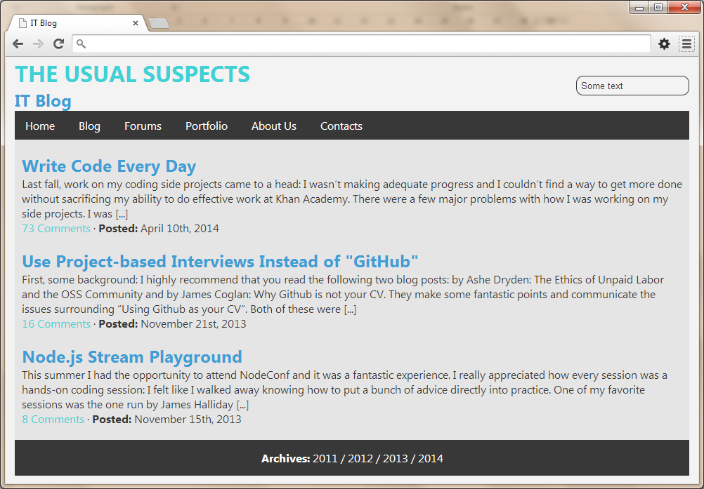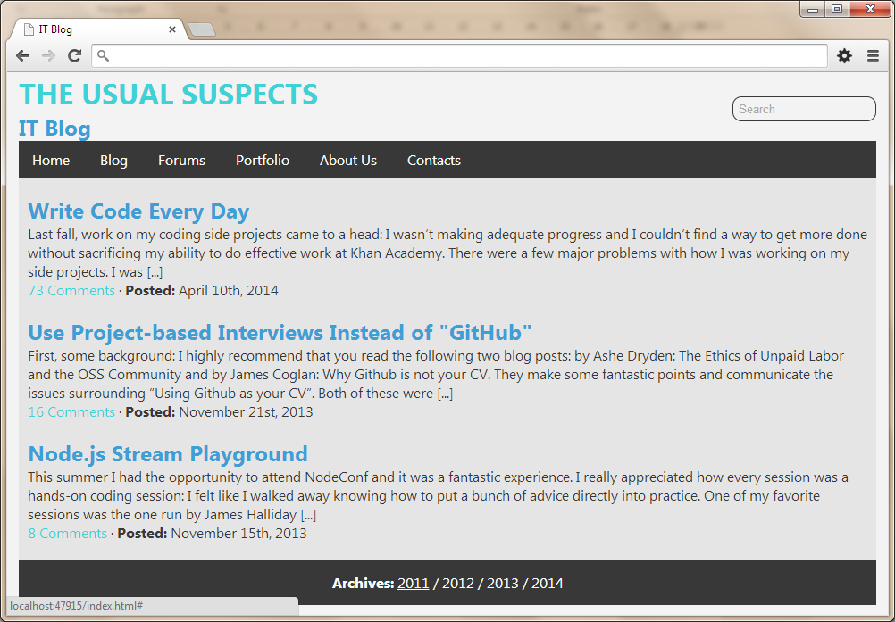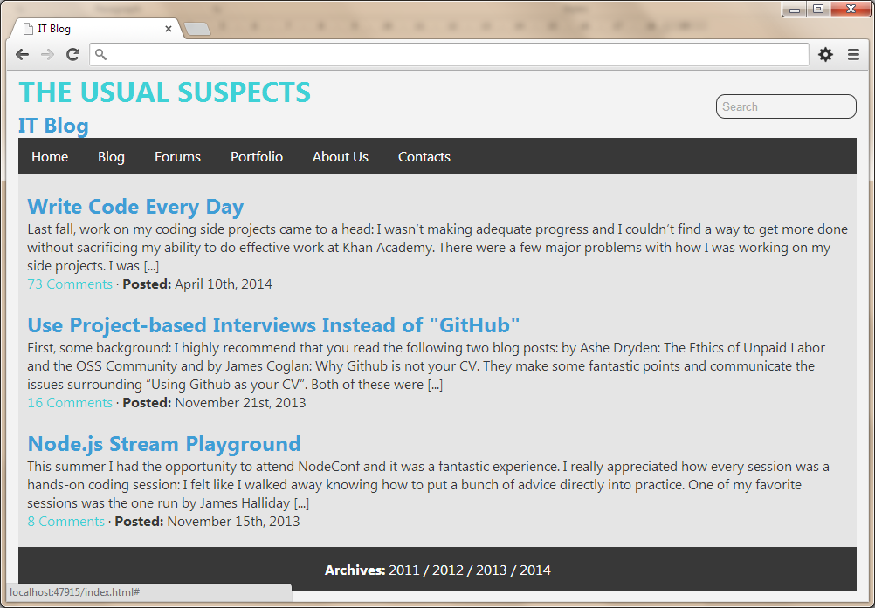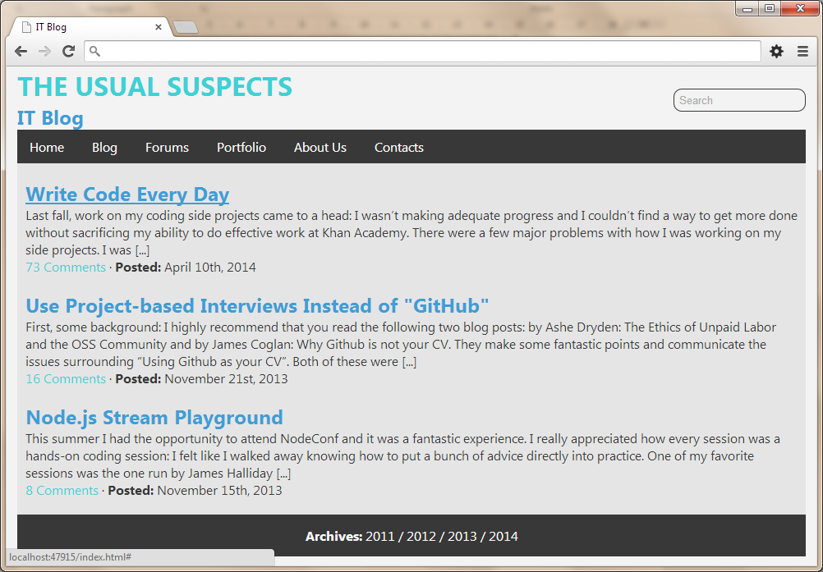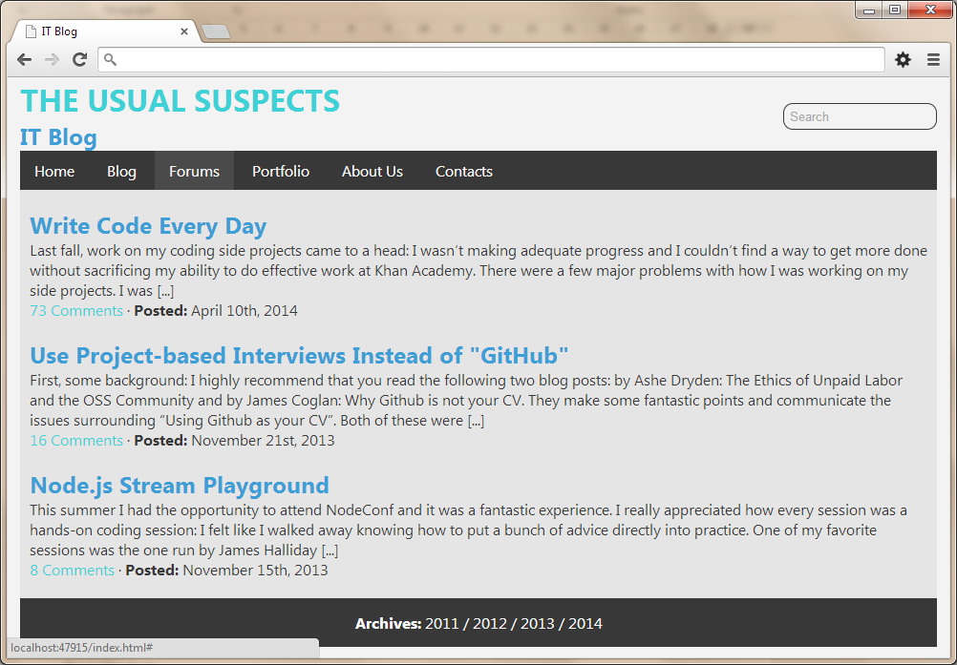

* The hand cursors in the screenshots are not part of your site, so please skip them.

### Input

You are given the above screenshots + the texts on the site, nothing else.

### Output

The output should be valid HTML5 + CSS3 + images that implement the above Web site.

### Constraints

* Font: Segoe UI / Open Sans / Arial / Tahoma / sans-serif.
* Fixed width: 960px.
* The site should open correctly in Chrome 35.
* Responsive design is not required.
* Pixel-perfect implementation is not required.